EXTENDED ABSTRACT TEMPLATE FOR THE 34TH INTERNATIONAL CONFERENCE ON ALPINE METEOROLOGY (12 PT BOLD CENTRED)

First (presenting) Author¹, Second B. Author², Third C. Author¹ (10 pt centred)

¹ World Meteorological Organization, Geneva, Switzerland
E-mail: myemailaddress1@wmo.org
² Meteorological Institute, University of Nowhere, Nowhere, Nomansland (10 pt centred)

Abstract: The abstract should briefly summarize the main contents of your contribution. Recommended maximum size 10 lines using Times new roman 9pt.

Keywords: ICAM, convection, mountainous area (9 pt in italics)

1 INTRODUCTION (headline in CAPITALS, 10 PT BOLD)

The extended abstracts will be gathered in the preprint volume for the 34th International Conference on Alpine Meteorology. In order to have similar format for all abstracts of the conference volume, this document gives some recommendations to the authors when elaborating their extended abstract.
The extended abstract should be formatted in A4 format (210 mm x 297 mm) with page margins of 25 mm on the left and right sides and 25 mm on the top and bottom. The maximum allowed size is 2 pages. Pages must not be numbered as the pagination will be done during the edition process for the full preprint volume.
The first page must begin with the paper title in capital letters centred. All authors' names and affiliations appear just below the title. The email address is only given for the first author. An abstract and keywords directly follow.
The text should be divided in several sections, e.g. INTRODUCTION, DATA AND METHODS (or MODEL SETUP for numerical modelling papers), RESULTS and CONCLUSION. The title of each section should be in capital letters. Sections can be divided in sub-sections with subtitles. The text must be in a single column format. For the body, the text must be single-spaced and justified, using preferably Times new Roman font. Sizes are specified at various locations. It should be structured in paragraphs, new paragraphs begin indented without an empty line. The paper should be written in English. SI units should be used.
References will appear at the end of the extended abstract. List citations alphabetically in the reference section. Three examples of citations are given in this document (Bougeault et al. 2001, Houze 1993, Schwitalla et al. 2007). Acknowledgements is an optional item placed just before the references section.

2 TABLES, FIGURES AND EQUATIONS

2.1 Tables and figures (10 pt bold)

A caption must be provided for each table and figure. Captions should be below the figures/tables and must be numbered (Tab. 1; Fig. 1). Figures may be provided in colours.

2.2 Equations

Equations should be marked with numbers at the right side, equation (1) is an example:

ax + b = c (1)

Test Table | Column 1 | Column 2 | Column 3 | Column 4
Line 01 | 1 | 2 | 3 | 4
Line 02 | 5 | 6 | 7 | 8
Line nn

Table 1. Most meaningful example of a brilliant table with columns and lines filled with a mimimum of quantitative information (entries in 10 pt; caption in 9 pt).
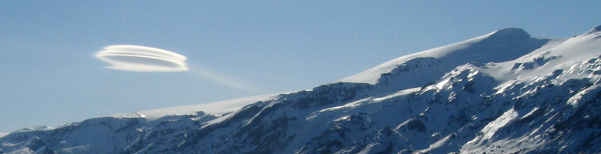

Figure 1. Eyjafjallajökull glaciers and an altocumulus lenticularis. Photo: Hálfdán Ágústsson (9 pt).

3 SUBMISSION OF EXTENDED ABSTRACT

The extended abstract should be produced with MS-Word, using the provided template (ICAM-ExtAbsTemplate.docx) on the ICAM 2017 web page (http://vedur.org/index.php/icam/downsloads). Of course, other word processing systems can be used as well, in that case, the authors are encouraged to follow the recommendations given in this example. The file should be converted in pdf-format before submitting your abstract to icam@vedur.org.
Please submit your extended abstract not later than 1 July 2017. Note that if you do not submit an extended abstract, your contribution will not appear in the Volume of Extended Abstracts. Please use the following naming convention to help us producing the Volume of Extended Abstracts:

ICAM-Name_of_first_author-{Oral|PosterCode}.pdf

Your Oral|PosterCode is given in the programme.

4 CONCLUSIONS

If all authors follow these guidelines as much as they find feasible, the Volume of Extended Abstracts will have a professional, semi-uniform appearance and can be produced without too much extra work. It will assist all participants to select the most interesting topics from the conference programme and serve as a valuable reference after the conference.

Acknowledgements: (9pt italics)
We thank all contributors for their cooperation on a voluntary basis..

REFERENCES (in 9 pt; second line indented for better distinction)

Bougeault, P., P. Binder, A. Buzzi, R. Dirks, R. Houze, J. Kuettner, R. B. Smith, R. Steinacker, and H. Volkert, 2001: The MAP Special Observing Period. Bull. Amer. Meteorol. Soc. 82 , 433–462.
Houze, R. A., Jr. 1993: Cloud dynamics, International Geophysics series, Volume 53, Academic Press, 573 pp.
Schwitalla, T., G. Zängl, H.-S. Bauer, and V. Wulfmeyer, 2007: Convective initiation in the Black Forest region in high-resolution MM5 simulations. Proc. 29th Intern. Conf. on Alpine Meteorology, Chambery, France, 261–264.

